.



<Title: 3 Layer (Base, Design and Profile) Architectural Specification Template>

<Version>.<Revision>.<Errata>

**Modular Architectural Specification**

Effective XXXX, 2024

Author: <Primary>

Author: <Secondary, etc. Delete if unnecessary>

# Version History

Note, refer to the OCP Contribution Versions, Revisions and Errata best practices documentation. Generally speaking, Versions and revisions are made to this document and logged here. Errata is a separate document such that the contribution specification document it refers to was not revised. Ex: Version 1, Errata E1

| **Date** | **Version #** | **Author** | **Description** |
| --- | --- | --- | --- |
|  |  |  |  |
|  |  |  |  |
|  |  |  |  |
|  |  |  |  |
|  |  |  |  |
|  |  |  |  |
|  |  |  |  |

# 

# Current Template Version:

**3 Layer (Base, Design and Product) Architectural Specification Template V1.4.0**

Effective November 2024

**Table of Contents**

**Version History 2**

**Current Template Version: 2**

**1. License 6**

1.1. Open Web Foundation (OWF) CLA 6

**1. Acknowledgements 7**

**2. Compliance with OCP Tenets 8**

2.1. Openness 8

2.2. Efficiency 8

2.3. Impact 9

2.4. Scale 9

2.5. Sustainability 9

**3. Scope 11**

3.1. Introduction to System Architecture 11

3.3. Base Architectural Specification Layer 14

3.4. Architectural Design Specification Layer 15

3.5. Profile Specification Layer 16

**4. Overview 18**

**5. Base Architectural Specifications 19**

**5.1. Repository Location (Strongly Recommended) 19**

**5.2. Goals, Requirements, Use Cases, Applications, Technical Objectives, Promising Techniques, Design Principles 19**

**5.3. Environmental, Regulatory and Compliance and Requirements 20**

**5.4. Physical/Logical Requirements 20**

**5.5. Special Mechanical/Thermal Design Requirements 20**

**5.6. Scaling: Horizontal and Vertical 21**

**5.7. Resilience/Redundancy 21**

**5.8. Interfaces 22**

5.8.1. Signal List 22

5.8.2. Rear Side Power, I/O, Expansion Board and Midplane Subsystems 23

**5.9. Prescribed Materials 23**

**5.10. System Firmware/Software 24**

**5.11. Hardware Management 24**

**5.12. Compliance 25**

**5.13. Security 25**

**5.14. Software Support 26**

**5.15. References (recommended) 26**

**6. Design Architectural Specifications 27**

**6.1. Repository Location (Strongly Recommended) 27**

**6.2. Requirements, Use Cases, Applications, Technical Objectives, Promising Techniques, Design Principles 27**

**6.3. Environmental, Regulatory and Compliance and Requirements 28**

**6.4. Physical/Logical Requirements 29**

**6.5. Special Mechanical/Thermal Design Requirements 29**

**6.6. Scaling: Horizontal and Vertical 30**

**6.7. Resilience/Redundancy 30**

**6.8. Interfaces 30**

6.8.1. Signal List 31

6.8.2. Rear Side Power, I/O, Expansion Board and Midplane Subsystems 32

**6.9. Prescribed Materials 32**

**6.10. System Firmware/Software 33**

**6.11. Hardware Management 33**

**6.12. Compliance 34**

**6.13. Security 34**

**6.14. Software Support 35**

**6.15. References (recommended) 35**

**7. Profile Specifications 36**

7.1. Repository Information 36

**Please identify OCP GitHub repository information for the Product Specifications. 36**

**7.2. Environmental Regulatory Compliance and Requirements 36**

**7.3. Physical Specifications 37**

**7.3.1. Mechanical 38**

7.3.2. Rack Compatibility 38

7.3.3. General Requirements 38

**7.4. Electrical Requirements 39**

**7.5. Thermal Design Requirements 39**

**7.6. Interfaces 40**

7.6.1. Signal List 40

7.6.2. Rear Side Power, I/O, Expansion Board and Midplane Subsystems 41

**7.7. Onboard Power System 41**

**7.8. Configurations 42**

**7.9. Prescribed Materials 42**

**7.10. System Firmware 42**

**7.11. Hardware Management 43**

**7.12. Compliance 43**

**7.13. Security 44**

**7.14. Software Support 45**

**7.15. References (recommended) 45**

**Appendix A - Checklist for Steering Committee (SC) approval of this Specification (to be completed by contributor(s) of this Spec) 46**

**Appendix B-__ <supplier name> - OCP Supplier Information and Hardware Product Recognition Checklist 47**

**Appendix C - Contribution Process FAQs 49**

# 

# License

THE UPDATED DEFAULT CONTRIBUTOR LICENSE AGREEMENT (CLA) IS [**OWFa 0.9**](https://146a55aca6f00848c565-a7635525d40ac1c70300198708936b4e.ssl.cf1.rackcdn.com/images/ed0befaf86bee2568ad720ff4a9a554d1f4260f7.pdf). PLEASE VERIFY THE CORRECT CLA/FSA IS USED AND EXECUTED FOR THIS CONTRIBUTION.

## Open Web Foundation (OWF) CLA

Contributions to this Specification are made under the terms and conditions set forth in **Modified Open Web Foundation Agreement 0.9 (OWFa 0.9)**. (As of October 16, 2024) (“Contribution License”) by:

**[Contributor Name(s) or Company name(s)]**

Usage of this Specification is governed by the terms and conditions set forth in **Modified OWFa 0.9 Final Specification Agreement (FSA)** (As of October 16, 2024) **(“Specification License”).**

You can review the applicable Specification License(s) referenced above by the contributors to this Specification on the OCP website at <https://www.opencompute.org/contributions/templates-agreements>.

​​For actual executed copies of either agreement, please contact OCP directly.

**Notes**:

The above license does not apply to the Appendix or Appendices. The information in the Appendix or Appendices is for reference only and non-normative in nature.

NOTWITHSTANDING THE FOREGOING LICENSES, THIS SPECIFICATION IS PROVIDED BY OCP "AS IS" AND OCP EXPRESSLY DISCLAIMS ANY WARRANTIES (EXPRESS, IMPLIED, OR OTHERWISE), INCLUDING IMPLIED WARRANTIES OF MERCHANTABILITY, NON-INFRINGEMENT, FITNESS FOR A PARTICULAR PURPOSE, OR TITLE, RELATED TO THE SPECIFICATION. NOTICE IS HEREBY GIVEN, THAT OTHER RIGHTS NOT GRANTED AS SET FORTH ABOVE, INCLUDING WITHOUT LIMITATION, RIGHTS OF THIRD PARTIES WHO DID NOT EXECUTE THE ABOVE LICENSES, MAY BE IMPLICATED BY THE IMPLEMENTATION OF OR COMPLIANCE WITH THIS SPECIFICATION. OCP IS NOT RESPONSIBLE FOR IDENTIFYING RIGHTS FOR WHICH A LICENSE MAY BE REQUIRED IN ORDER TO IMPLEMENT THIS SPECIFICATION. THE ENTIRE RISK AS TO IMPLEMENTING OR OTHERWISE USING THE SPECIFICATION IS ASSUMED BY YOU. IN NO EVENT WILL OCP BE LIABLE TO YOU FOR ANY MONETARY DAMAGES WITH RESPECT TO ANY CLAIMS RELATED TO, OR ARISING OUT OF YOUR USE OF THIS SPECIFICATION, INCLUDING BUT NOT LIMITED TO ANY LIABILITY FOR LOST PROFITS OR ANY CONSEQUENTIAL, INCIDENTAL, INDIRECT, SPECIAL OR PUNITIVE DAMAGES OF ANY CHARACTER FROM ANY CAUSES OF ACTION OF ANY KIND WITH RESPECT TO THIS SPECIFICATION, WHETHER BASED ON BREACH OF CONTRACT, TORT (INCLUDING NEGLIGENCE), OR OTHERWISE, AND EVEN IF OCP HAS BEEN ADVISED OF THE POSSIBILITY OF SUCH DAMAGE.

# Acknowledgements

The Contributors of this Specification would like to acknowledge the following for their feedback:

List all companies or individuals who may have assisted you with the specification by providing feedback and suggestions but did not provide any IP.

| DELETE THIS BLOCK BEFORE SUBMITTING |
| --- |
| INSTRUCTIONS FOR THE FOLLOWING SECTIONS:   * The following sections, 2-5 are required for contribution. * Replace the section text (keep titles) * Please describe how this Specification complies to the following OCP tenets. Compliance is required for at least four of the five tenets (Sustainability is a required tenet). The ideals behind open sourcing stipulate that everyone benefits when we share and work together. Any open source project is designed to promote sharing of design elements with peers and to help them understand and adopt those contributions. There is no purpose in sharing if all parties aren't aligned with that philosophy. The OCP Incubation Committee will look beyond the contribution for evidence that the contributor is aligned with this philosophy. The contributor actions, past and present, are evidence of alignment and conviction to all the tenets. |

# Compliance with OCP Tenets

Please describe how this Specification complies to the following OCP tenets. Compliance is required for at least four of the five tenets (Sustainability is a required tenet). The ideals behind open sourcing stipulate that everyone benefits when we share and work together. Any open source project is designed to promote sharing of design elements with peers and to help them understand and adopt those contributions. There is no purpose in sharing if all parties aren't aligned with that philosophy. The OCP Incubation Committee will look beyond the contribution for evidence that the contributor is aligned with this philosophy. The contributor actions, past and present, are evidence of alignment and conviction to all the tenets.

A full explanation of the OCP core tenets can be seen [here](https://146a55aca6f00848c565-a7635525d40ac1c70300198708936b4e.ssl.cf1.rackcdn.com/images/bf648bb75091907147e76846cad590f402660d2e.pdf).

## Openness

The measure of openness is the ability of a third party to build, modify, or personalize the device or platform from the contribution. OCP strives to achieve completely open platforms, inclusive of all programmable devices, firmware, software, and all mechanical and electrical design elements, including ancillary, external components or tools such as software utilities necessary to modify or use design contributions. Barriers to achieving this goal should be constantly addressed and actions taken to remove anything that prevents an open platform. Openness can also be demonstrated through collaboration and willingness to share, seek feedback, and accept changes to design and specification contributions under consideration. Ensure this contribution can be extended and enhanced by others.

## Efficiency

Continuous improvement has been a fundamental value of the industry. New contributions (and updates to existing contributions) shall be more efficient than existing or prior generation contributions. Efficiency can be measured in many ways - OpEx and CapEx reduction, performance, modularity, capacity, power or water consumption, raw materials, utilization, size or floorspace are some examples. The goal is to express efficiency with clear metrics, valued by end-users, when the contribution is proposed.

## Impact

OCP contributions should have a transformative impact on the industry. This impact can come from introducing new technology, time-to-market advantage of technology, and/or enabling technology through supply chains that deliver to many customers in many regions of the world. New technologies are impactful when such technology is enabled through a global supply channel. One example is the NIC 3.0 specification which achieved global impact by having over 12 companies author, adopt, and supply products that conformed to the specification. Another example is emerging and open security features that establish and verify trust of a product

## Scale

OCP contributions should be designed such that end products may be easily implemented and/or deployed, irrespective of quantity, with minimal intervention. Ensure all necessary tools, such as supporting documentation, etc., are included in the final contribution.

## Sustainability

OCP contributions must be sustainable. Submissions should maximize transparency of

environmental impacts of the contribution, with the aspiration of improvement over time.

Other focuses:

* Conscientious use of our natural resources (land, air, power, water and materials)
* Fostering positive societal impacts
* Minimizing Environmental Harm

Practically this can be realized in a base specification as high level design requirements, or architectural decisions, or design for circularity, as a few examples, that reflect this intent. For a Design Specification it might be refined and expanded as practical choices such as in materials, component families, power saving features, circularity features, materials by weight, operational data, etc, and in Product Specifications as specific components, power saving modes, circularity processes, sustainability types of labeling and others. These are merely examples.

## 

# Scope

| DELETE THIS BLOCK BEFORE SUBMITTING |
| --- |
| INSTRUCTIONS FOR THE FOLLOWING SECTIONS:   * This scope section contents have been added for author’s information. * Replace the section text (keep titles) with the relevant scoping information intended for this specification document. |

The purpose of this template is to define a specification that includes the Base, Design and Product as layers, in a single document. This organization allows contributors to make a single contribution while also allowing others to reuse and extend parts of this specification. For example after the initial release of your contribution in this document, a subsequent modification can be made and a derivative specification can be created by referring to this document.

## Introduction to System Architecture

The system architecture serves as the foundational blueprint outlining the structure, components, and interactions within a software system. It delineates the high-level design decisions and technical framework necessary for the development, deployment, and maintenance of the system. This section of the specification document provides an overview of the system architecture, elucidating its purpose, key components, design principles, and architectural patterns employed.

* Purpose

The system architecture elucidates the overarching design strategy aimed at achieving the system's functional and non-functional requirements. It delineates the structural organization of the system, facilitating a comprehensive understanding of its constituent elements and their interrelationships.

* Key Components

This section identifies the primary building blocks of the system architecture, encompassing hardware components, software modules, data storage mechanisms, communication protocols, and external interfaces. Each component's role and contribution to the system's functionality are elucidated, establishing a clear comprehension of the system's composition.

* Design Principles

The design principles underlying the system architecture are articulated to guide the development process effectively. These principles encompass modularity, scalability, flexibility, maintainability, and performance optimization, ensuring that the architecture aligns with the system's objectives and future evolution.

* Architectural Patterns

Architectural patterns employed within the system architecture, such as client-server, microservices, event-driven, or layered architecture, are delineated. Each pattern's suitability to the system's requirements and its implications on system behavior and performance are discussed, providing insights into the rationale behind architectural choices.

* Interactions and Dependencies

The interactions among system components and their dependencies are elucidated to illustrate the flow of data, control, and communication within the system. This includes the identification of critical interfaces, protocols, and data exchange formats, ensuring seamless interoperability among system elements.

* Constraints and Assumptions

Any constraints or assumptions governing the system architecture, such as hardware limitations, regulatory compliance requirements, or technological dependencies, are explicitly stated. Understanding these constraints is essential for mitigating risks and ensuring the feasibility and viability of the proposed architecture.

* Evolution and Maintenance

Considerations regarding the evolution and maintenance of the system architecture are discussed, addressing aspects such as extensibility, adaptability, and future scalability. Strategies for accommodating changes, incorporating new features, and addressing emerging technological trends are delineated to ensure the longevity and relevance of the architecture.

By providing a comprehensive overview of the system architecture, this document serves as a cornerstone for stakeholders, enabling effective collaboration, informed decision-making, and successful system implementation.

* 1. **Modular Architecture Contribution Pattern**

The general modular contribution hierarchy is:

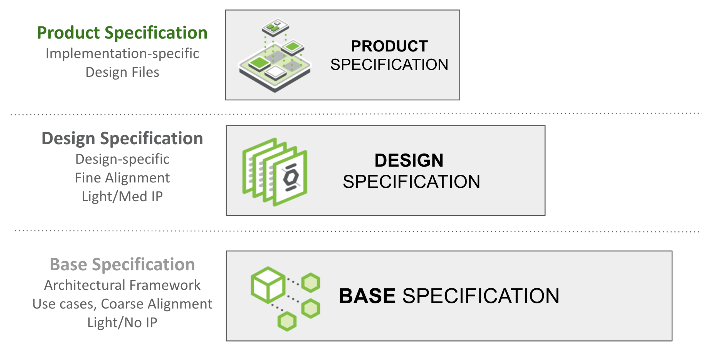

Figure 1: Modular Contribution Specification Layers

These modular specification templates generally refer to system/subsystem level design. This template’s purpose is to create a framework for architectural specification, from the high level or base to the very prescriptive product layer in what’s called a Profile specification. Figure 1 shows the Modular Contribution Specification Layers and Figure 2 shows the derivative Architectural Contribution Specification Layers.

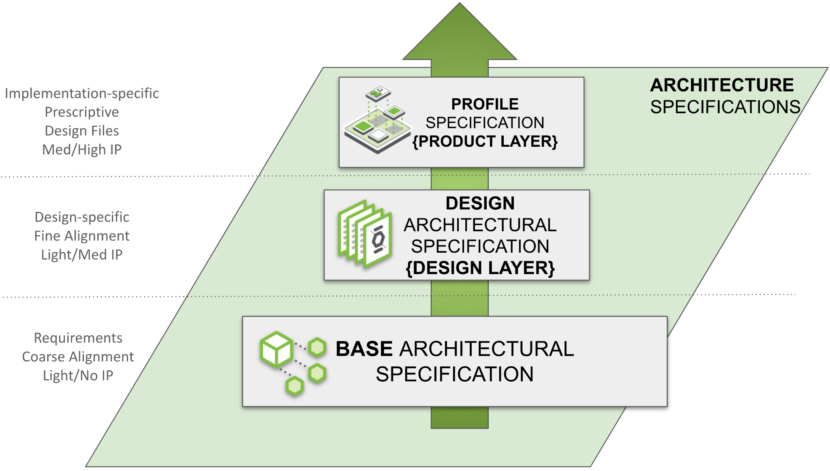

Figure 2: Modular Architectural Contribution Specifications

## Base Architectural Specification Layer

The Base Specification is an architectural framework for coarse alignment— a requirements description for flexible hardware and software modules/layers to interoperate. Market requirements drive Base Specifications. Without defining details of a specific design, the Base Specification may be light on IP content. This structure enables and simplifies the process for multiple parties (including potential competitors) to engage in this phase.

Please see the [presentation](https://146a55aca6f00848c565-a7635525d40ac1c70300198708936b4e.ssl.cf1.rackcdn.com/images/4d14a1280e13c7dcf17123678eedc7e56053de96.pdf) and [recording](https://www.youtube.com/watch?v=IKqGFyE0V9E) on the Modular Contribution Process from the OCP Global Summit 2022 for more information.

This document defines the technical details for one of the following types of specifications:

* Base Specification for a de-facto standard (new standard with no hardware product)
* Base Specification for an intended aggregation of physical <hardware product type> subsystems
* modification of an existing base specification (state which existing spec is being modified)
  + either a revision update or
  + a new version

Note: Any supplier seeking OCP recognition for a hardware product must be 100% compliant with the system level Base requirements and subsequent design and product specifications as described. **It is not envisaged that OCP product recognition is extended to an architectural specification at this time**.

The defining difference between the Hardware System/Subsystem level specifications and this architectural specification is that the intention is for this to include multiple systems into a single architecture or an aggregation of disaggregated subsystems. An example of this is a mobile wireless core. The core is a group of disaggregated subsystems; there are interfaces in between these subsystems and even other cores. Together these disparate subsystems (media servers, databases, policy services etc…) act as a single system and according to transaction specific rules (home call, roaming voice call etc…) The definition of this is outside the scope of a Hardware Base Specification, thus an Architectural Base Specification is defined here to be a container for these designs. The components may be an aggregation of OCP only or OCP and non-OCP specified systems.

## Architectural Design Specification Layer

The Design Specification captures customer requirements for finer alignment by building on the Base Specification (Spec). If a Base Specification provides general requirements and design goals, the Design Specification has detail that further defines what specific role this contribution plays, and enough detailed design information such as high level schematics, layouts, flow diagrams, etc that enables end users to begin the journey to realize this in the market. One or more parties may join to develop detailed design spec and they don’t necessarily need to be the same that worked on the base specifications. Compared to the Base Specification, this effort typically contains significantly more detail such as future roadmaps and IP-related information. This group may choose to use an open or closed Contribution License Agreement (CLA), or even have a multi-party NDA on their own (outside of the OCP umbrella) adjacent to their corporate practices of developing products/services.

Design Specifications can be reused! I.e., if one contributor uses an indoor design specification, another team could reuse and make an outdoor specification. Having the same Base Specification for several Design Specifications will help increase the commonality of physical and logical interfaces to meet a set of common infrastructure hw/sw/fw requirements while allowing gen-to-gen variations or product differentiation.

This document defines the technical details for one of the following types of specifications:

* A new Architectural Design Specification for an Architectural Base Specification
* modification of an existing specification (state which existing spec is being modified)
  + either a complete version update or
  + a minor revision update
* a specification with additional detail over the Base Specification for a <architecture type> . This includes expansion of an existing specification without changes to the existing specifications.

The components may be an aggregation of OCP only or OCP and non-OCP specified systems.

## Profile Specification Layer

The Profile Specification captures exact requirements including specific mandatory support, chosen or available options, all design, and any build files, typically building on an Architectural Design Specification. Typically even fewer companies will engage to create a single profile specification. The goal is to ultimately increase the total number of products that meet a Design Specification (derived from a Base Specification) and likely increase the amount of targeted solutions derived from a common Base/Design level specification. A profile of a product/service typically goes through much effort for qualification and mass-production/service readiness beyond what specified in a typical design spec.

Profile Specifications can be reused! I.e., assuming the base and design specifications allow, if one contributor creates an architecture based on 110VAC design specifications, another team could reuse and make an -48VDC based architecture specification.

It is possible for the profile specification to apply to a single system/subsystem. This is likely as a Product Specification. For example a product/service with a design specification that has multiple configurations or options may have a Profile Specification which defines a specific implementation. In this use, these templates for profile and product specification are somewhat interchangeable. The intended target of this template is to provide a definite configuration of Base/Design Architectural specifications.

A Product profile (based on a Product Specification) may be submitted to OCP for “OCP Accepted™” or “OCP Inspired™” designation (with different levels of collateral such as a Design Package).

Please see the [presentation](https://146a55aca6f00848c565-a7635525d40ac1c70300198708936b4e.ssl.cf1.rackcdn.com/images/4d14a1280e13c7dcf17123678eedc7e56053de96.pdf) and [recording](https://www.youtube.com/watch?v=IKqGFyE0V9E) on the Modular Contribution Process from the OCP Global Summit 2022 for more information.

This document defines the technical details for one of the following types of specifications:

* Product Profile Specification for an intended physical <hardware product type>
* Architectural Profile Specification for a specific configuration (intended physical/logical implementation) of Architectural Design Specification.
* modification of an existing product specification (state which existing spec is being modified)
  + either a complete version update or
  + a minor revision update
* a detailed prescriptive specification for a <product type> with a product typically being available in 120 days of approval of this Spec.

Note: Any supplier seeking OCP recognition, for example OCP Accepted, for a hardware product, must be using a product spec that is 100% compliant with the preceding Base requirements, Design specification and these Product Specifications as described.

The components may be an aggregation of OCP only or OCP and non-OCP specified systems.

| DELETE THIS BLOCK BEFORE SUBMITTING |
| --- |
| INSTRUCTIONS FOR THE FOLLOWING SECTIONS:   * The following (Sections 5-8 are required to document features and functions of the contributed system, subsystem, platform, card, component or other unit as appropriate- and are broken out into layers. * The layout of the sections has some boilerplate and random examples. These are illustrative only. Please rearrange, add, delete, and change as necessary to describe the contribution. * Be sure to complete only the incremental requirements for each subsequent layer. (ex: Assume Base Specification and include only changes in the Product Specifications, etc…) * Please use the OCP Terminology Guidelines for Inclusion and Openness. * No NDA (Non-disclosure Agreement) or confidential material is to be included in this document, including charts and included materials. This will be an OPEN document. |

# 

# Overview

Describe your contribution and the modularity of this spec within the framework of modular specification process (this might be the openness tenet too) Include the problems it addresses. Explain its utility within the Open Compute Project ecosystem.

# 

# Base Architectural Specifications

# Repository Location (Strongly Recommended)

*It is highly recommended that OCP projects participate in a collaborative development process. OCP has GitHub resources available, with access control if/as needed, for this development process. Please request a repository for your contribution from your project leads.*

*Please identify OCP GitHub repository information.*

# Goals, Requirements, Use Cases, Applications, Technical Objectives, Promising Techniques, Design Principles

*Please describe the problem that is being addressed and provide supporting detail to help the reader understand the end goals, methods, requirements, etc…*

*\*Source: Zhang, Zhengquan et al. “6G Wireless Networks: Vision, Requirements, Architecture, and Key Technologies.” IEEE Vehicular Technology Magazine 14 (2019): 28-41.*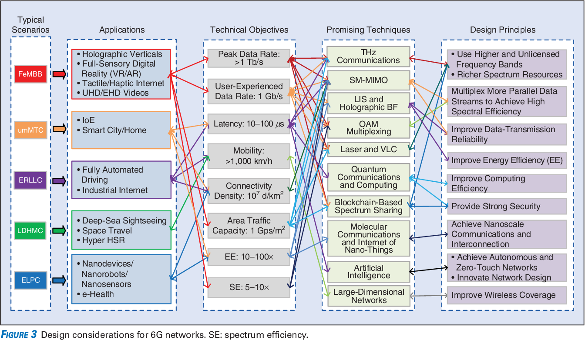

Sample Requirements Diagram

# Environmental, Regulatory and Compliance and Requirements

*Please describe any environmental regulations or requirements for any platform boards and full system, if applicable..*

*Note to author of this specification: This section can include the following but is not limited to the below items:*

* *UL/CE/NRTL/FCC/IEC/EN/etc Requirements*
* *RoHS/WEE directives, REACH regulations*
* *NEBS compliance requirements*
* *Operating temperature range*
* *Storage temperature range*
* *Transportation temperature range*
* *Shock and Vibration requirements*
* *Operating Altitude*

# Physical/Logical Requirements

*Please describe the physical requirements for your contribution. This may be the limitations of the physical envelope and logical considerations such as functionality, statefulness, clouds, etc…*

*If this specification defines a chassis type system, be sure to include the description of the chassis and associated modules, midplane, backplanes etc….*

*Note to author of this specification: This section can include the following but is not limited to the below items:*

* *Block and flow Diagrams*
* *Form Factor Requirements*
* *Figures & Illustrations*

# Special Mechanical/Thermal Design Requirements

*Please describe the thermal design requirements for your contribution and any CFD and/or thermal models etc...*

*Note to author of this specification: Examples include:*

* *Cooling Media*
* *Flow Management*
* *Fan Controls*

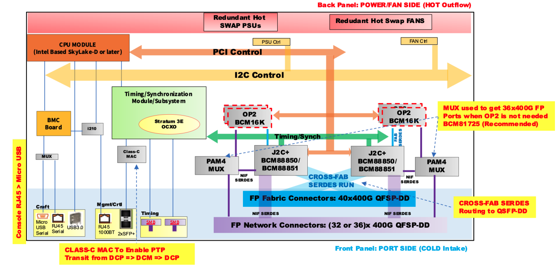

Sample Block Diagram

# Scaling: Horizontal and Vertical

*Please describe the ways the system extends, both vertically (ex: unit feature or capacity expansion) and horizontally (ex: across shelves, racks, regions) etc…*

# Resilience/Redundancy

*Please describe the ways the system survives failures and faults.*

*Note to author of this specification: Examples include:*

* *N+1 Redundancy*
* *Pooling*

# Interfaces

*Please describe the I/O System of the contribution, be sure to delineate the control and data planes. Block diagrams here.*

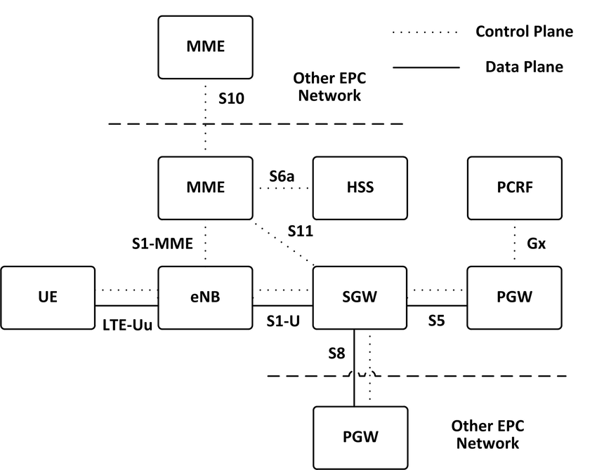

Sample Block Diagram Showing Interfaces

*Source: Virtualised EPC for on-demand mobile traffic offloading in 5G environments - Scientific Figure on ResearchGate. Available from: https://www.researchgate.net/figure/The-Reference-Architecture-for-the-3GPP-Evolved-Packet-Core_fig1_292149641

## Signal List

*Note to author of this specification: Examples only*

* *Power and Ground*
* *Synchronization/Clocks*
* *PCIe*
* *i2C/i3C*
* *GPIO*
* *USB 3.0*

## Rear Side Power, I/O, Expansion Board and Midplane Subsystems

*Please describe any modular design implementation requirements of the contribution.*

*Note to author of this specification: This section can include the following but is not limited to the below items:*

* *​​Overview of Footprint and Population Options*
* *Rear Side Connectivity*
* *Midplane*
* *Expansion*
* *Fixed, redundant, modular, pluggable, adapter?*
* *Power, Grounding etc…*

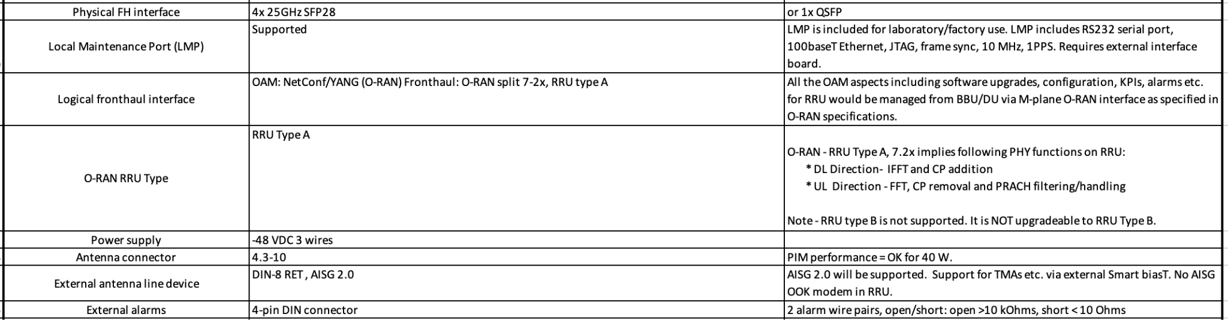

Example: Dual-Band RRU External Interface Requirements

# Prescribed Materials

*Please list any prescribed materials in your contribution. Specific components that are being referenced but not contributed.*

*Note to author of this specification: This section can include the following but is not limited to the below items:*

* *Disallowed components*

*Any specifically required components with no substitution (Ex: IC Intel JHL8540 or greater for Thunderbolt 4 compliance)*

# System Firmware/Software

*Please document firmware/software function, and necessary features, licensing and distribution rights, explanation of ownership rights, system build utilities, test regime explanations, standards compliance, options for changing firmware configurations, and how firmware upgrades can be accomplished.*

*Note to author of this specification: This section can include the following but is not limited to the below items:*

* *Operating System, booting Functionality of the firmware/software*
* *Feature Requirements*

# Hardware Management

*Please document the hardware management implementation of your contribution. Include Firmware (BIOS) optional Board Management Controller (BMC), Data Center Secure Control Modules (DC-SCM), etc.*

*Note to author of this specification: This section* ***should*** *include the following below items:*

* *Statement on whether the contribution supports out-of-band manageability.*
* *Statement on the modularity of the manageability architecture. (i.e. is an OCP management module used?)*

*Note to author of this specification: This section* ***can*** *include the following but is not limited to the below items:*

* *Architecture of out-of-band management*
  + *Dedicated or shared NIC*
  + *In which power state is the OOB management enabled*
* *A list of on-platform manageability interfaces:*
  + *Connections: I2C/I3C, SMBus, RMII,*
  + *Transport Protocol: MCTP, IPMI (KCS, BT, etc)*
  + *Commands constructs: PLDM …, IPMI, SPDM, CPER*
* *A list of components whose firmware which can updated programmatically*
  + *Which support failover/rollback mechanisms*
* *A list of diagnostic or management LEDs supported*
* *A list of minimum telemetry/sensors*
* *A list of minimum controls*
* *Whether conformance to OCP Profiles has been tested*
* *For Arm-based Servers, whether conformance to Arm Server Base Manageability Requirements Specification has been followed. If so, please also indicate the conformance level (e.g., M2)*

# Compliance

*Describe any required compliance here. For example: 3GPP 5G-NR Release 17, IEEE Precision Time Protocol 1599-2019.*

*This* ***mandatory*** *section is also applicable if there is a need to create a checklist for the consumers of the specification to adhere to in order for them to declare it complies to the requirements. This applies to any implementations (OCP Marketplace or not) that declare compliance with this specification.*

*(Example Compliance Table Follows)*

| ***ITEM*** | ***REQUIREMENT*** | ***REFERENCE*** | ***MANDATORY*** |
| --- | --- | --- | --- |
| *1* | *If scalable HPM depth >372.5mm (from origin), additional Zone 2 KOZs shall be*  *implemented.* | *10.3.2 (multiple items)* | *Y* |
| *2* | *Optional: The device shall only clear the Timestamp Origin field to 000b in the Timestamp (Feature*  *Identifier 0Eh) on a main power cycle or NVM Subsystem Reset (e.g., NSSR). The device*  *shall not clear the Timestamp Origin field on a power cycle of only AUX power.* | *NVMe-OPT-4* | *N* |
| *3* | *Any supplier seeking OCP recognition for a hardware product based on this specification*  *shall be 100% compliant* | *4* | *Y* |

# Security

*Please briefly describe security functionality that* ***your specification requires and recommends\*****.*

*Include a “required by” date on recommendations. Omit what doesn’t apply and add whatever*

*is missing. Remember, the greater the detail in this specification, the less flexibility is allowed during design and product specification.*

*Note to author of this specification: This section* ***can*** *include the following but is not limited to the below items:*

* *For cryptography, key derivation, key agreement, and hashing, identify*

*o Required algorithms, modes, strengths, and usage*

*o Required compliance with national or international standards*

*o Acceptable sources of entropy*

*o Acceptable certifications of algorithm implementations*

*o Recommended certifications of cryptographic modules*

*o Recommended safeguards against cryptanalysis by quantum computers*

* *Required flow of Secure Boot starting from hardware root(s) of trust*
* *Required measurements from hardware reset through firmware*
* *Required attestation protocols*
* *Acceptable environments and processes for provisioning keys and device secrets*
* *Acceptable processes for identifying CVEs and distributing field updates to address them*
* *Acceptable Secure Boot and Attestation key lifecycle management (from generation through*
* *revocation)*
* *Recommended standards for software bills of materials*
* *Recommended firmware recovery mechanisms*

*\*Required = Required now*

*Acceptable = Required now and chosen from a list of acceptable alternatives*

*Recommended = Recommended now, but required by a specified future date*

*Please find guidance and examples in the OCP Security Project documents on* [*Secure Boot*](https://www.opencompute.org/documents/secure-boot-2-pdf)*,* [*Attestation of System Components*](https://www.opencompute.org/documents/attestation-v1-0-20201104-pdf)*,* [*Common Security Threats*](https://www.opencompute.org/documents/common-security-threats-notes-1-pdf)*, and the* [*CSIS document on Secure Firmware Development Best Practices*](https://www.opencompute.org/documents/csis-firmware-security-best-practices-position-paper-version-1-0-pdf)*.*

All products seeking OCP Inspired™ or OCP Accepted™ Product Recognition shall have a

completed Security Profile in the latest Supplier Requirements Checklist. Whether the answer is

a yes or no, the profile must be completed. For the base specification, a statement about the intention for the contribution to comply with OCP Inspired™ or OCP Accepted™ Product Recognition requirements.

# Software Support

*Please identify any software required including notional architecture and features required to support the contribution in Bill of Materials format if incorporating multiple packages, as needed.*

*Identify any OCP GitHub repository information.*

# References (recommended)

[1] “Title”, publication year, publication journal/conference/standard, volume, pages, link to publication if available.

# Design Architectural Specifications

Reminder to authors, this section refines the previous section, so it’s unnecessary to strictly repeat the previous sections, only add what modifies and refines the previous. This section is for the Design Specifications. If a Base Specification provides general requirements and design goals, the Design Specifications has detail that further defines what specific role this contribution plays, and enough detailed design information such as high level board layouts, enumerations, etc that enables end users to utilize this part of the specifications to begin the journey to realize this design.

# Repository Location (Strongly Recommended)

*It is highly recommended that OCP projects participate in a collaborative development process. OCP has GitHub resources available, with access control if/as needed, for this development process. Please request a repository for your contribution from your project leads.*

*Please identify new repository information either by pointing back to the same repository in the base specifications and identifying new resources or providing additional repository information pertaining to this design specification.*

# Requirements, Use Cases, Applications, Technical Objectives, Promising Techniques, Design Principles

*Please restate/describe the problem, and provide a highly targeted scoping for the solution, both refining the high level information provided in the base specifications and any new requirements.*

*\*Source: Zhang, Zhengquan et al. “6G Wireless Networks: Vision, Requirements, Architecture, and Key Technologies.” IEEE Vehicular Technology Magazine 14 (2019): 28-41.*

Sample Requirements Diagram

# Environmental, Regulatory and Compliance and Requirements

*Please describe any environmental regulations or requirements for any platform boards and full system, if applicable..*

*Note to author of this specification: This section can include the following but is not limited to the below items:*

* *UL/CE/NRTL/FCC/IEC/EN/etc Requirements*
* *RoHS/WEE directives, REACH regulations*
* *NEBS compliance requirements*
* *Operating temperature range*
* *Storage temperature range*
* *Transportation temperature range*
* *Shock and Vibration requirements*
* *Operating Altitude*

# Physical/Logical Requirements

*Please describe the physical requirements for your contribution. This may be the limitations of the physical envelope and logical considerations such as functionality, statefulness, clouds, etc…*

*If this specification defines a chassis type system, be sure to include the description of the chassis and associated modules, midplane, backplanes etc….*

*Note to author of this specification: This section can include the following but is not limited to the below items:*

* *Block and flow Diagrams*
* *Form Factor Requirements*
* *Figures & Illustrations*

# Special Mechanical/Thermal Design Requirements

*Please describe the thermal design requirements for your contribution and any CFD and/or thermal models etc...*

*Note to author of this specification: Examples include:*

* *Cooling Media*
* *Flow Management*
* *Fan Controls*

**

Sample Block Diagram

# Scaling: Horizontal and Vertical

*Please describe the ways the system extends, both vertically (ex: unit feature or capacity expansion) and horizontally (ex: across shelves, racks, regions) etc…*

# Resilience/Redundancy

*Please describe the ways the system survives failures and faults.*

*Note to author of this specification: Examples include:*

* *N+1 Redundancy*
* *Pooling*

# Interfaces

*Please describe the I/O System of the contribution, be sure to delineate the control and data planes. Block diagrams here.*



Sample Block Diagram Showing Interfaces

*Source: Virtualised EPC for on-demand mobile traffic offloading in 5G environments - Scientific Figure on ResearchGate. Available from: https://www.researchgate.net/figure/The-Reference-Architecture-for-the-3GPP-Evolved-Packet-Core_fig1_292149641

## Signal List

*Note to author of this specification: Examples only*

* *Power and Ground*
* *Synchronization/Clocks*
* *PCIe*
* *i2C/i3C*
* *GPIO*
* *USB 3.0*

## Rear Side Power, I/O, Expansion Board and Midplane Subsystems

*Please describe any modular design implementation requirements of the contribution.*

*Note to author of this specification: This section can include the following but is not limited to the below items:*

* *​​Overview of Footprint and Population Options*
* *Rear Side Connectivity*
* *Midplane*
* *Expansion*
* *Fixed, redundant, modular, pluggable, adapter?*
* *Power, Grounding etc…*

**

Example: Dual-Band RRU External Interface Requirements

# Prescribed Materials

*Please list any prescribed materials in your contribution. Specific components that are being referenced but not contributed.*

*Note to author of this specification: This section can include the following but is not limited to the below items:*

* *Disallowed components*

*Any specifically required components with no substitution (Ex: IC Intel JHL8540 or greater for Thunderbolt 4 compliance)*

# System Firmware/Software

*Please document firmware/software function, and necessary features, licensing and distribution rights, explanation of ownership rights, system build utilities, test regime explanations, standards compliance, options for changing firmware configurations, and how firmware upgrades can be accomplished.*

*Note to author of this specification: This section can include the following but is not limited to the below items:*

* *Operating System, booting Functionality of the firmware/software*
* *Feature Requirements*

# Hardware Management

*Please document the hardware management implementation of your contribution. Include Firmware (BIOS) optional Board Management Controller (BMC), Data Center Secure Control Modules (DC-SCM), etc.*

*Note to author of this specification: This section* ***should*** *include the following below items:*

* *Statement on whether the contribution supports out-of-band manageability.*
* *Statement on the modularity of the manageability architecture. (i.e. is an OCP management module used?)*

*Note to author of this specification: This section* ***can*** *include the following but is not limited to the below items:*

* *Architecture of out-of-band management*
  + *Dedicated or shared NIC*
  + *In which power state is the OOB management enabled*
* *A list of on-platform manageability interfaces:*
  + *Connections: I2C/I3C, SMBus, RMII,*
  + *Transport Protocol: MCTP, IPMI (KCS, BT, etc)*
  + *Commands constructs: PLDM …, IPMI, SPDM, CPER*
* *A list of components whose firmware which can updated programmatically*
  + *Which support failover/rollback mechanisms*
* *A list of diagnostic or management LEDs supported*
* *A list of minimum telemetry/sensors*
* *A list of minimum controls*
* *Whether conformance to OCP Profiles has been tested*
* *For Arm-based Servers, whether conformance to Arm Server Base Manageability Requirements Specification has been followed. If so, please also indicate the conformance level (e.g., M2)*

# Compliance

*Describe any required compliance here. For example: 3GPP 5G-NR Release 17, IEEE Precision Time Protocol 1599-2019.*

# Security

*Please briefly describe security functionality that* ***your specification requires and recommends\*****.*

*Include a “required by” date on recommendations. Omit what doesn’t apply and add whatever*

*is missing. Remember, the greater the detail in this specification, the less flexibility is allowed during design and product specification.*

*Note to author of this specification: This section* ***can*** *include the following but is not limited to the below items:*

* *For cryptography, key derivation, key agreement, and hashing, identify*

*o Required algorithms, modes, strengths, and usage*

*o Required compliance with national or international standards*

*o Acceptable sources of entropy*

*o Acceptable certifications of algorithm implementations*

*o Recommended certifications of cryptographic modules*

*o Recommended safeguards against cryptanalysis by quantum computers*

* *Required flow of Secure Boot starting from hardware root(s) of trust*
* *Required measurements from hardware reset through firmware*
* *Required attestation protocols*
* *Acceptable environments and processes for provisioning keys and device secrets*
* *Acceptable processes for identifying CVEs and distributing field updates to address them*
* *Acceptable Secure Boot and Attestation key lifecycle management (from generation through*
* *revocation)*
* *Recommended standards for software bills of materials*
* *Recommended firmware recovery mechanisms*

*\*Required = Required now*

*Acceptable = Required now and chosen from a list of acceptable alternatives*

*Recommended = Recommended now, but required by a specified future date*

*Please find guidance and examples in the OCP Security Project documents on* [*Secure Boot*](https://www.opencompute.org/documents/secure-boot-2-pdf)*,* [*Attestation of System Components*](https://www.opencompute.org/documents/attestation-v1-0-20201104-pdf)*,* [*Common Security Threats*](https://www.opencompute.org/documents/common-security-threats-notes-1-pdf)*, and the* [*CSIS document on Secure Firmware Development Best Practices*](https://www.opencompute.org/documents/csis-firmware-security-best-practices-position-paper-version-1-0-pdf)*.*

All products seeking OCP Inspired™ or OCP Accepted™ Product Recognition shall have a

completed Security Profile in the latest Supplier Requirements Checklist. Whether the answer is

a yes or no, the profile must be completed. For the base specification, a statement about the intention for the contribution to comply with OCP Inspired™ or OCP Accepted™ Product Recognition requirements.

# Software Support

*Please identify any software required including notional architecture and features required to support the contribution in Bill of Materials format if incorporating multiple packages, as needed.*

*Identify any OCP GitHub repository information.*

# References (recommended)

[1] “Title”, publication year, publication journal/conference/standard, volume, pages, link to publication if available.

# Profile Specifications

Reminder to authors, the intended use of a profile is to be prescriptive in definition of options, configurations and so on. To the extent this section refines any previous sections, it’s unnecessary to strictly repeat the previous sections, only add what modifies the previous. This section, the Profile Specifications, requires further detail such as but not limited to bills of materials, any component part numbers, supporting gerber/design, software, tools and any other files required to be able to produce the contribution.

## Repository Information

*It is highly recommended that OCP projects participate in a collaborative development process. OCP has GitHub resources available, with access control if/as needed, for this development process. This is essential at the Product Specification stage to keep important design information readily accessible and to enable future collaboration on potential improvements and revisions.*

# *Please identify OCP GitHub repository information for the Product Specifications.*

# Environmental Regulatory Compliance and Requirements

*Please describe any environmental regulations or requirements for any platform boards and full system, if applicable..*

*Note to author of this specification: This section can include the following but is not limited to the below items:*

* *UL/CE/NRTL/FCC/IEC/EN/etc Requirements*
* *RoHS/WEE directives, REACH regulations*
* *NEBS compliance requirements*
* *Operating temperature range*
* *Storage temperature range*
* *Transportation temperature range*
* *Shock and Vibration requirements*
* *Operating Altitude*

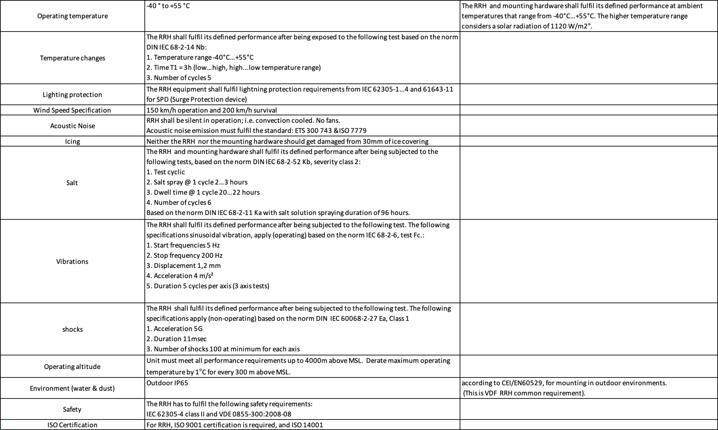

Example Outdoor Equipment Environmental Requirements

# Physical Specifications

*Please describe the physical requirements for your contribution. This may be the limitations of the physical envelope.*

*If this specification defines a chassis type system, be sure to include the description of the chassis and associated modules, midplane, backplanes etc….*

*Note to author of this specification: This section can include the following but is not limited to the below items:*

* *Block Diagrams*
* *Form Factor Requirements*
* *Figures & Illustrations*

**

Sample Block Diagram

# Mechanical

*Please describe any key mechanical requirements of your contribution.*

## Rack Compatibility

*Please describe if your contribution will be used in a rack installation. If the contribution is rack mountable, the specification must be compliant with one of the following OCP approved rack types: OpenRack (V3.X and beyond), EIA-310, OpenEdge.*

## General Requirements

*Note to author of this specification: This section can include the following but is not limited to the below items:*

* *Chassis*
* *Single sled/double sled*

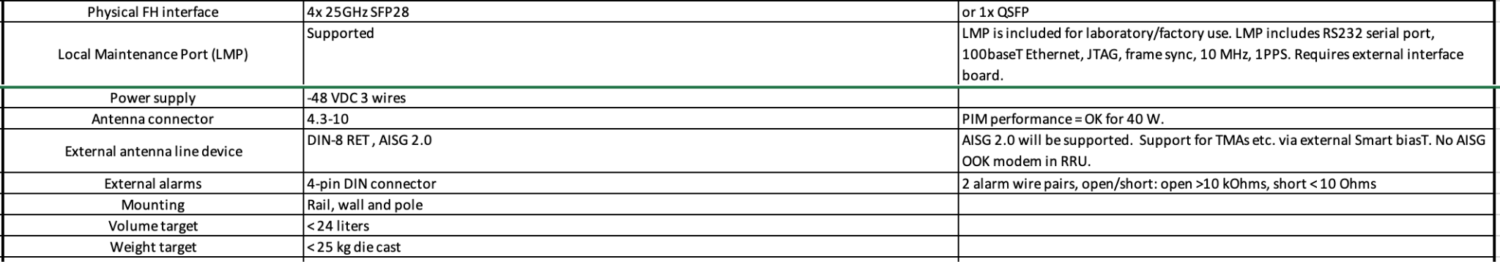

Example Dual-Band RRU Mechanical Requirements

# Electrical Requirements

*Please describe general electrical power requirements. Example: Power Input envelope +48VDC, 110VAC, peak/average power, etc…*

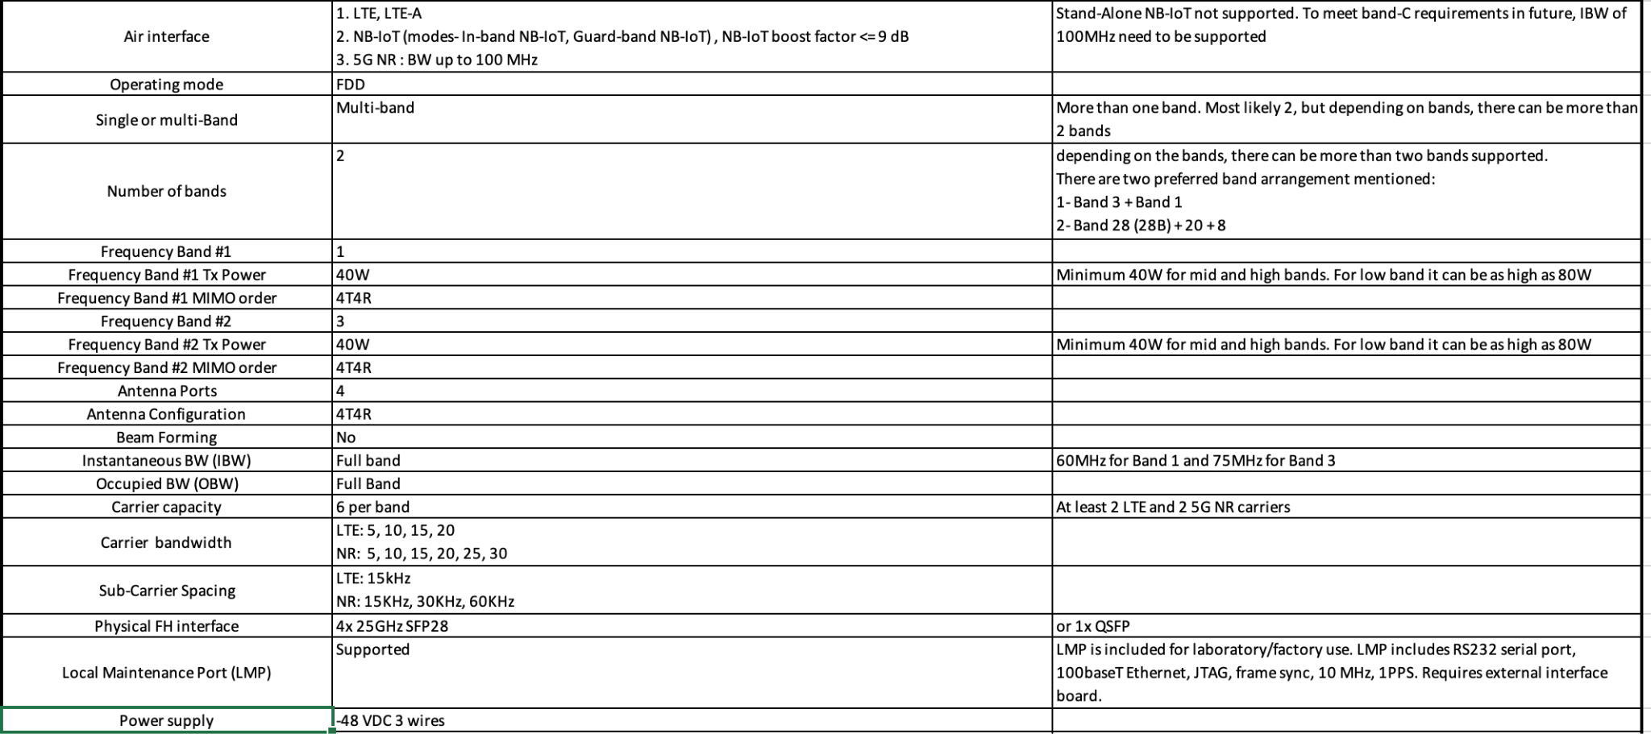

Example Dual-Band RRU Electrical Requirements

# Thermal Design Requirements

*Please describe the thermal design requirements for your contribution and any CFD and/or thermal models etc...*

*Note to author of this specification: Examples include:*

* *Cooling Media*
* *Flow Management*
* *Fan Controls*

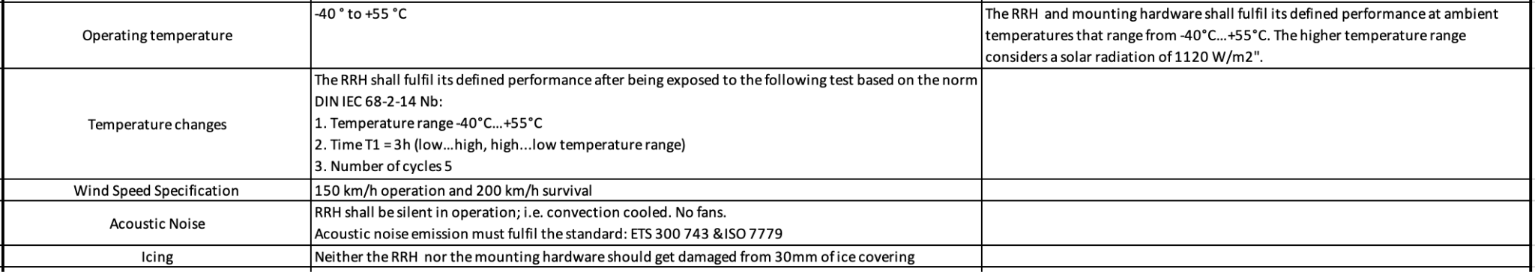

Example Dual-Band RRU Thermal Requirements

# Interfaces

*Please describe the I/O System of the contribution, be sure to delineate the control and data planes. Block diagrams here.*

**

Sample Block Diagram Showing Interfaces

## Signal List

*Note to author of this specification: Examples only*

* *Power and Ground*
* *Synchronization/Clocks*
* *PCIe*
* *i2C/i3C*
* *GPIO*
* *USB 3.0*

## Rear Side Power, I/O, Expansion Board and Midplane Subsystems

*Please describe any modular design implementation requirements of the contribution.*

*Note to author of this specification: This section can include the following but is not limited to the below items:*

* *​​Overview of Footprint and Population Options*
* *Rear Side Connectivity*
* *Midplane*
* *Expansion*
* *Fixed, redundant, modular, pluggable, adapter?*
* *Power, Grounding etc…*

**

Example Dual-Band RRU External Interface Requirements

# Onboard Power System

*Please describe the architecture of the power systems and requirements in your contribution.*

*Note to author of this specification: This section can include the following but is not limited to the below items:*

* *Voltage Regulation*
* *Power Management*
* *Input voltages*
* *Hot swap controller circuit*
* *Hard drive power*
* *Power Tree*
* *Power Policy*
* *Power Budget*
* *Platform Budget*
* *Capacitive Load*

**

Example Dual-Band RRU Power Supply Requirements

# Configurations

*Please define and list any/all configurations that comprise this profile.*

# Prescribed Materials

*Please list any prescribed materials in your contribution. Specific components that are being referenced but not contributed.*

*Note to author of this specification: This section can include the following but is not limited to the below items:*

* *Disallowed components*

*Any specifically required components with no substitution (Ex: IC Intel JHL8540 or greater for Thunderbolt 4 compliance)*

# System Firmware

*Please document firmware function, and necessary features, licensing and distribution rights, explanation of ownership rights, system build utilities, test regime explanations, standards compliance, options for changing firmware configurations, and how firmware upgrades can be accomplished.*

*Note to author of this specification: This section can include the following but is not limited to the below items:*

* *BIOS Chip*
* *BIOS Feature Requirements*

# Hardware Management

*Please document the hardware management implementation of your contribution. Include Firmware (BIOS) optional Board Management Controller (BMC), Data Center Secure Control Modules (DC-SCM), etc.*

*Note to author of this specification: This section* ***should*** *include the following below items:*

* *Statement on whether the contribution supports out-of-band manageability.*
* *Statement on the modularity of the manageability architecture. (i.e. is an OCP management module used?)*

*Note to author of this specification: This section* ***can*** *include the following but is not limited to the below items:*

* *Architecture of out-of-band management*
  + *Dedicated or shared NIC*
  + *In which power state is the OOB management enabled*
* *A list of on-platform manageability interfaces:*
  + *Connections: I2C/I3C, SMBus, RMII,*
  + *Transport Protocol: MCTP, IPMI (KCS, BT, etc)*
  + *Commands constructs: PLDM …, IPMI, SPDM, CPER*
* *A list of components whose firmware which can updated programmatically*
  + *Which support failover/rollback mechanisms*
* *A list of diagnostic or management LEDs supported*
* *A list of minimum telemetry/sensors*
* *A list of minimum controls*
* *Whether conformance to OCP Profiles has been tested*
* *For Arm-based Servers, whether conformance to Arm Server Base Manageability Requirements Specification has been followed. If so, please also indicate the conformance level (e.g., M2)*

# Compliance

*Please list any/all compliance requirements for this profile.*

*All Products seeking OCP Accepted™ Product Recognition shall have source code and binary*

*blobs submitted for BMC, if applicable.*

*The BMC management source code shall be uploaded at:*

*https://github.com/opencomputeproject/Hardware-Management/[vendor_name]/[product_name]*

# Security

*Please briefly describe security functionality that* ***your specification requires and recommends\*****.*

*Include a “required by” date on recommendations. Omit what doesn’t apply and add whatever*

*is missing. Remember, the greater the detail in this specification, the less flexibility is allowed during design and product specification.*

*Note to author of this specification: This section* ***can*** *include the following but is not limited to the below items:*

* *For cryptography, key derivation, key agreement, and hashing, identify*

*o Required algorithms, modes, strengths, and usage*

*o Required compliance with national or international standards*

*o Acceptable sources of entropy*

*o Acceptable certifications of algorithm implementations*

*o Recommended certifications of cryptographic modules*

*o Recommended safeguards against cryptanalysis by quantum computers*

* *Required flow of Secure Boot starting from hardware root(s) of trust*
* *Required measurements from hardware reset through firmware*
* *Required attestation protocols*
* *Acceptable environments and processes for provisioning keys and device secrets*
* *Acceptable processes for identifying CVEs and distributing field updates to address them*
* *Acceptable Secure Boot and Attestation key lifecycle management (from generation through*
* *revocation)*
* *Recommended standards for software bills of materials*
* *Recommended firmware recovery mechanisms*

*\*Required = Required now*

*Acceptable = Required now and chosen from a list of acceptable alternatives*

*Recommended = Recommended now, but required by a specified future date*

*Please find guidance and examples in the OCP Security Project documents on* [*Secure Boot*](https://www.opencompute.org/documents/secure-boot-2-pdf)*,* [*Attestation of System Components*](https://www.opencompute.org/documents/attestation-v1-0-20201104-pdf)*,* [*Common Security Threats*](https://www.opencompute.org/documents/common-security-threats-notes-1-pdf)*, and the* [*CSIS document on Secure Firmware Development Best Practices*](https://www.opencompute.org/documents/csis-firmware-security-best-practices-position-paper-version-1-0-pdf)*.*

All products seeking OCP Inspired™ or OCP Accepted™ Product Recognition shall have a

completed Security Profile in the latest Supplier Requirements Checklist. Whether the answer is

a yes or no, the profile must be completed. For the base specification, a statement about the intention for the contribution to comply with OCP Inspired™ or OCP Accepted™ Product Recognition requirements.

# Software Support

*Please identify any software required and their configurations. This is also the place to list any tools used to validate the design and include test and validation using virtual simulation, design decisions based upon digital models, or proof of manufacturability via 3-D tools.*

# References (recommended)

[1] “Title”, publication year, publication journal/conference/standard, volume, pages, link to publication if available.

# Appendix A - Checklist for Steering Committee (SC) approval of this Specification (to be completed by contributor(s) of this Spec)

Complete all the checklist items in the table with links to the section where it is described in this spec or an external document .

| **Item** | **Status or Details** | **Link to detailed explanation** |
| --- | --- | --- |
| Is this contribution entered into the OCP Contribution Portal? | Yes or No | If no, please state the reason. |
| Was it approved in the OCP Contribution Portal? | Yes or No | If no, please state the reason. |
| Is there a Supplier(s) that is building a product based on this Spec? (Supplier must be an OCP Solution Provider) | Yes or No | List Supplier Name(s) |
| Will Supplier(s) have the product available for GENERAL AVAILABILITY within 120 days? | Yes or No | If more time is required, please state the timeline and reason for extension request.  Please have each Supplier fill out Appendix B. |

# 

# Appendix B-__ <supplier name> - OCP Supplier Information and Hardware Product Recognition Checklist

(to be provided by each supplier seeking OCP recognition for a Hardware Product based on this specification)

Company:

Contact Info:

Product Name:

Product SKU#:

Link to Product Landing Page:

The following is needed for OCP hardware product recognition:

**For OCP Inspired™**

* All Suppliers must be an OCP Member. All corporate membership levels are eligible.
* Declare product is 100% compliant with specification
* Complete the [OCP Inspired™ Product Recognition Checklist](https://docs.google.com/spreadsheets/d/1p7g_bPWzgXDDTkxbOEOkLrbvfKmqVWspKOi7J20yJcE/copy?resourcekey=0-UWRTqqnBa3i6BcSNTDJfmA#gid=963873675), which includes hardware management conformance checks and security profile.

**For OCP Accepted™**

* All Suppliers must be an OCP Member. All corporate membership levels are eligible.
* Complete the [OCP Accepted™ Product Recognition Checklist](https://docs.google.com/spreadsheets/d/1SNqQYCta4CVsZsZcRRVR5A779YyCHxA2gLSINlFtnTs/copy#gid=963873675), which includes hardware management conformance checks, security profile and open system firmware conformance checks.
* Submit a design package meeting [OCP Hardware Design Guideline Contribution Checklist](https://docs.google.com/document/u/0/d/1SdLlXxn_jz__t8I33ATraYvHDYX3go3w_rR4LJ1PNTE/edit) (if not already submitted by the contributor). If already submitted, declare the product is 100% compliant with the design package.
* Submit a firmware package including a firmware image, build scripts, documentation, test results and a tool that verifies modifications
* Submit the BMC source code, if applicable to product type

Please complete the OCP Inspired™ Product Recognition Submission Checklist or OCP Accepted™ Product Recognition Checklist and the following table.

| **Item** | **Details** | **Links** |
| --- | --- | --- |
| Which product recognition? | OCP Accepted™ or OCP Inspired™ | Provide link for the appropriate Product Checklist |
| If OCP Accepted™, who provided the Design Package? |  | Link to OCP Contribution Database |
| Where can a potential adopter purchase the product? |  | Link to OCP Marketplace |

# 

# Appendix C - Contribution Process FAQs

As a contributor to a hardware specification, here are some questions that often come up.

1. What type of hardware specification am I contributing to OCP? Is it any of the below?
   1. base, design and product specification for a de-facto standard (new standard with no hardware product on the horizon)
   2. base, design and product specification for an intended physical <hardware product type> (product may be coming but within the next 1-2 years)
   3. modification of an existing specification (state which existing spec is being modified)
      1. either a complete revision update or
      2. a minor version update
   4. design spec (based on an existing base specification) with more refined design details (product coming in 12-15 months)
   5. a detailed product specification for a <hardware product type> for a very specific product being available in 3-6 months of approval of this Spec
   6. A Base, Design and Product Specification in a single document.
   7. If none of the above, please contact OCP Staff for better direction.
2. How do I know if what I am contributing will be accepted by OCP?
   1. Before contributing any specifications, please contact either OCP Staff (Michael Schill, Rob Coyle or Bijan Nowroozi) or the Project Lead for the Project that best represents your contribution. For example, if you are contributing a Server Specification, please contact one of the Server Project Leads. You can see all the Projects [here](https://www.opencompute.org/projects).
   2. They will help you with your contribution and help you navigate the process.
3. What is the contribution process for my hardware spec?
   1. Follow the flow for your spec type [here](https://docs.google.com/presentation/d/1PlXGLhCdgVEGWQ0hLYdAQEH5qCScwYij/edit#slide=id.g10e20dc1292_0_101).
   2. This flow is subject to change so please check with the OCP Staff for more information or any questions.
4. What if my spec is not developed yet and I want to collaborate with other companies?
   1. Please contact either OCP Staff [contributors@opencompute.org](mailto:contributors@opencompute.org) or the Project Lead for the Project that best represents your contribution.
   2. They will help you find other collaborators and help you with the contribution process for a multi-party contribution.
5. I have a question on the Contribution License Agreement.
   1. Please contact OCP Staff and we can help you with questions.
6. Do I need to have a product in order to contribute a spec?
   1. Please see Q1. Some types of specs do not require an immediate product. Some do. Please work with the OCP Staff on better direction on your specification type.